Slide 1 - S6 Presentation - Project Description (Intro Company, Business Problem for IS - 1 minute max)

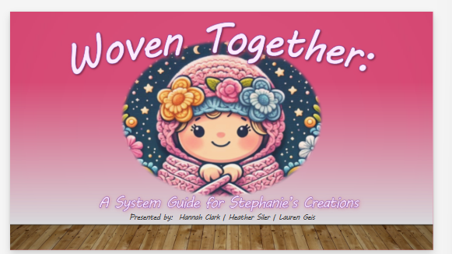

* Presenter:
* Slide Notes:
* Transition to: ???

Slide 2 - S6 Presentation - Project Description (Intro Company, Business Problem for IS - 1 minute max)

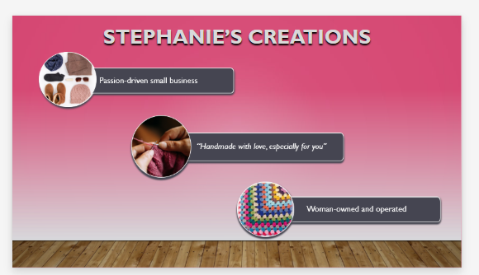

* Presenter:
* Slide Notes:
* Transition to: ???

Slide 3 - S6 Presentation - Project Description (BPA/BPI/BPR & why - 1 minute max)

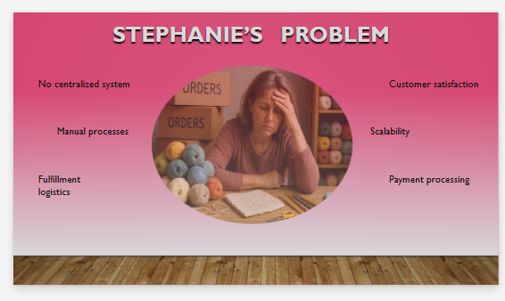

* Presenter:
* Slide Notes:
* Transition to: ?????

Slide 4 - S6 Presentation - Project Description (BPA/BPI/BPR & why - 1 minute max)

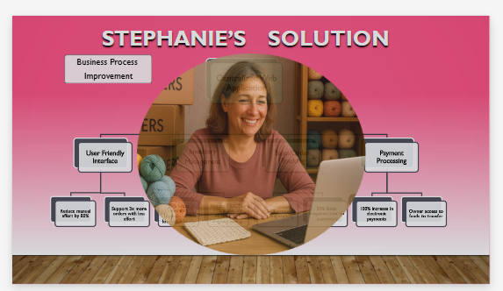

* Presenter:
* Slide Notes:
* Transition to: ?????

Slide 5 - S6 Presentation - Problem Analysis (Use Case Diagram - 1 minute max)

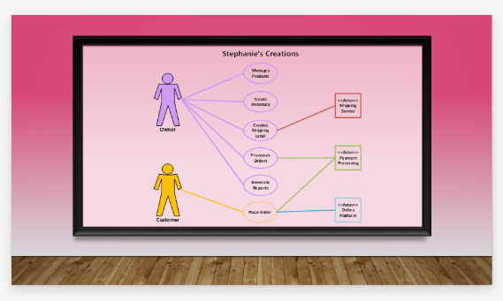

* Presenter:
* Slide Notes:
* Transition to: ?????

Slide 6 - S6 Presentation - Design (DFD L0 only - 1 minute max)

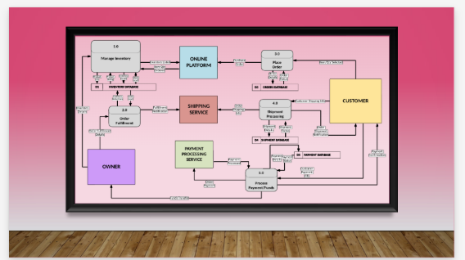

* Presenter:
* Slide Notes:
* Transition to: ?????

Slide 7 – S6 Presentation - Implementation (Demo of Entire System 5-7 minute max)

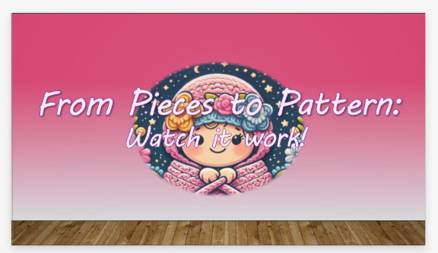

* Presenter:
* Slide Notes:

**Demo Script: Stephanie's Creations System**

**(0:00 - 0:30) Introduction**

* Now, we will demonstrate the new Stephanie's Creations system. This system is designed to streamline operations, from order management to shipping and inventory control, all in one user-friendly platform.
* We will cover the key features in the next few minutes, focusing on how Stephanie and any future team members will use them daily.

**(0:30 - 1:30) User Login/Sign Up**

* First, let's look at how users access the system. As you can see, we have a clear login screen with 'LOGIN' and 'SIGN UP' options.
* **(If showing Login):** For existing users, the process is simple. You enter your username (which is your email) and password in the respective fields and click the dark pink 'Sign In' button. (Demonstrate this quickly)
* **(If showing Sign Up):** New users can easily create an account by clicking the white 'SIGN UP' button. They'll be prompted to enter a username (email) and a secure password, and then click the dark pink 'SIGN UP' button." (Demonstrate this quickly)
* If a user forgets their password, there are password reset options available (or they can contact the administrator).

**(1:30 - 3:00) Order Management**

* Once logged in, one of the core functions is Order Management. Let's click on the 'Orders' button.
* Here, Stephanie can easily add new orders. She enters the customer's first and last name, selects the item from a drop-down list, chooses the color(s), and clicks 'Add Item'. (Demonstrate adding a simple order)
* The system allows for easy modification. If there's a mistake, items can be deleted and re-added. Finally, clicking 'Add Order' submits the order.

**(3:00 - 4:00) Shipping Management**

* Next, let's move to the 'Shipping' section. This is where Stephanie can track the progress of each order.
* For each order, you can see the customer's details, items, payment, and expected delivery. The shipping status can be easily updated by clicking the 'NEXT' button to move it forward (Ordered -> In Transit -> Out for Delivery -> Delivered) or the 'PREVIOUS' button to move it backward if needed." (Demonstrate a quick status change)

**(4:00 - 5:30) Inventory Management**

* The 'Inventory' section is crucial for managing stock levels. Clicking the 'Inventory' button takes us there."
* Adding a new item is straightforward. You enter the product name, assign a unique SKU, specify the quantity, and select the color(s). The system also provides low stock alerts (less than 30) and restock needed alerts (10 or less), which is very helpful. (Demonstrate adding a simple item)

**(5:30 - 6:00) Navigation and Sign Out**

* The system has a simple navigation menu, accessible via the 'hamburger menu' on the top left, allowing you to quickly switch between 'Home', 'Orders', 'Shipping', and 'Inventory'. (Demonstrate this)
* Finally, to sign out, you simply click the 'Sign Out' button in the top right corner.

**(6:00 - 7:00) Conclusion**

* This system provides Stephanie's Creations with the tools to manage their business efficiently. We've covered the core functionalities, but there are more detailed features as well.
* Transition to: ?????

Slide 8 - S6 Presentation - Post-Implementation (Lessons learned by group - 2 minutes)

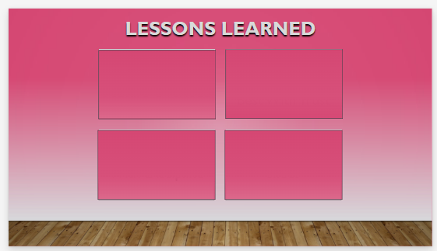

* Presenter:
* Slide Notes:
* Transition to: ?????

Slide 9 - S6 Presentation - Post-Implementation (Explanation of challenges, problems, discoveries - 1 minutes)

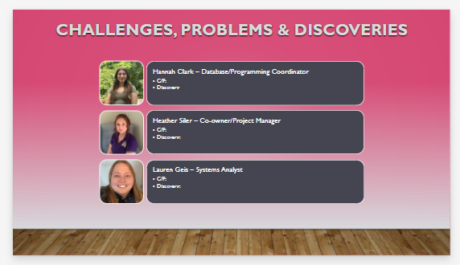

* Presenter:
* Slide Notes:
* Transition to: ?????

Slide 10 - S6 Presentation - Q&A

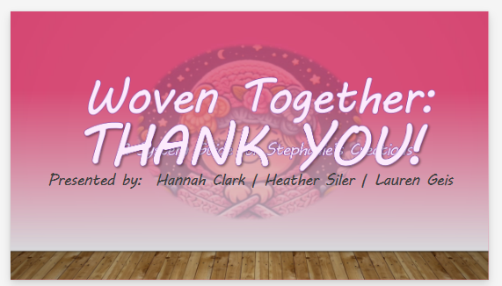

* Presenter:
* Slide Notes:
* Transition to: ?????